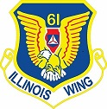
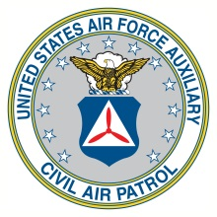
HEADQUARTERS ILLINOIS WING
CIVIL AIR PATROL
UNITED STATES AIR FORCE AUXILIARY
P O Box 4027
St. Charles IL 60174-9082

Date goes here

